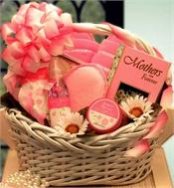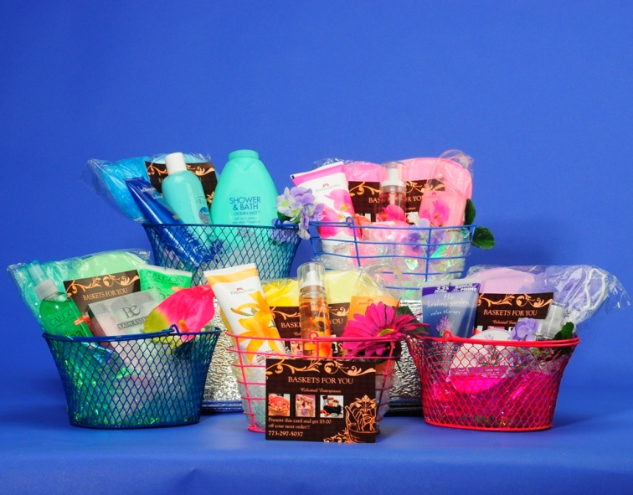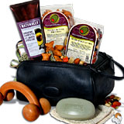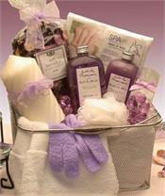

**Are you looking for that special gift, but not sure of what to give? Have Celestial Enterprises create**

**“Baskets for You”!**

Celestial Enterprises ”Baskets for You” • Bronzeville • Chicago, Illinois 60653 • 773-297-5037 • celestialenterprise.mcge8@gmail.com • www.celestialenterprises.com

*Each customize Gift Basket is designed with you in mind. The starting categories for our gift baskets are the most popular. Here are some of the basic descriptions of each basket contents. Each gift basket has a color scheme, lotions, creams, splashes, body scrubs, towels, head bands, slippers, etc. All Gift baskets range in price starting at $20 & up!! Costs vary on concept, design, and content. Secure a Gift Basket today…put the joy into your gift giving!!*

Celestial Enterprises

“Customized Gift Baskets with you in mind”